What to do when your patient may have a weak internet connection

Here are some small things you can do to help improve calls when you have some patients with low internet speeds or old devices with slower CPU’s
- Before the call with your patient switch your Video Quality Setting to Low Definition in Account Settings > Room Settings. (not SD or HD, you can always change on the live call if the connection seems stable)
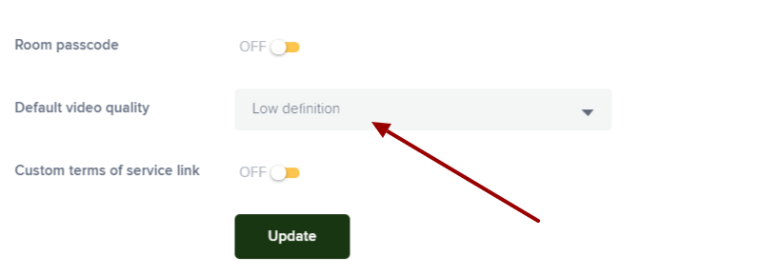
- If possible, try to have the patient join via laptop or desktop that can be connected via Ethernet, this will get the most out of any internet connection. (You can get Ethernet adaptors for Tablets and phones as well )
  - Wired (Ethernet) vs. Wireless - Improve your internet connection: https://www.loom.com/share/6c979e2d2d2c455fa46d7b520e60267d
- If a participant is not speaking please have them mute their microphones, if they do not need to be seen until talking please encourage them to mute the Mic and pause their video feed. When using Screen Share, turn off your Video feed until done with the screen sharing.
- Make the browser tab you are using for the video call a little smaller, taking it off full screen will reduce the pixels used, improve clarity and reduce bandwidth needed.
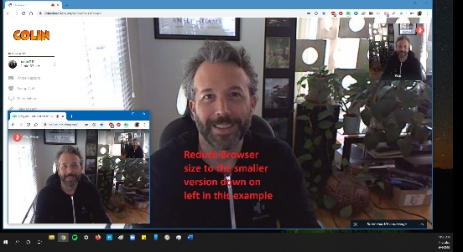
- Please suggest the patient’s phones, tablets and laptops have a good battery charge on the device. The CPU processing live video calls requires a good amount of battery power if the device is not plugged in.
- This is a little more detailed: High CPU usage is one of the simplest issues that can impact a computer’s performance. If you find that high CPU usage persists—even in support of standard processes—you may simply need a faster computer. You can also reduce CPU load by adding more RAM to the laptop/Desktop, which can give your CPU a much-needed break.

The key things that make for a poor experience on group calls are as follows:
- Low internet speeds: below 10-15MPBS on Download or Upload, Latency above 50ms for an optimal call
  - https://speed.measurementlab.net/#/
- Old Devices with poor processing power (CPU’s) can have a tough time with demanding live video, especially the larger the number of people on the call. These Devices tend to have older Operating systems, slower processors, out of date browsers and more.
  - Phones (iPhone or Android): Around 2-3+ years old
  - Tablets: Around 2-3+ years old
  - Laptops and Desktops: around 4+ years old
- People Connecting on phones or tablets over a cellular network: cellular data plans, in some cases are slower than WiFi (ask if they can join a WiFi network before the call) If not get the best cellular data plan signal you can, even simply turning off the data plan and back on can connect you to the closest cell tower.
  - Get a stronger signal if on a data plan: 20-easy-ways-improve-cell signal
  - Tips to improve your Data plan Signal: easy-fixes-to-improve cell-phone-signal
- For WiFi: A good rule of thumb is to be able to see your wireless router from where you are sitting, this means nothing is impeding the signal to your device.

